CLINICAL NUTRITION DIM3’s PLATFORM EVALUATION

This short document summarized the root and potential of an evaluation project between Dim3 and an hospital institution interested in clinical nutrition management innovation

Dim3 is a MedTech company focused on the fight against clinical malnutrition. Dim3's products and services consist of a digital platform for real-time diagnosis and monitoring of clinical nutrition problems, to facilitate clinical decision-making processes. Monitoring is constant throughout the patient's care pathway.

Dim3 provides the first commercial CE-marked clinical nutrition monitoring platform, from hospital to home care, enabling the highest level of monitoring to increase clinical nutrition compliance. By optimizing the quality of nutritional care throughout the patient journey, this platform is the transmission belt that enables data continuity at all stages of the patient journey between hospital and home care.

The Dim3 solution is based on a software package (Nutrow/Scorso) and an electronic device (Feedim) integrated into users' electronic medical record systems. Nutrow and Scorso are web-based applications, while Feedim is an Internet of Medical Things (IoMT) device capturing data of Feeding pumps.
They can be deployed or scaled on hospital/homecare premises or in the cloud, with state-of-the-art cybersecurity built in.
All standards applicable to the design and manufacture of medical devices form the basis of Dim3's development principles .

CLINICAL MALNUTRITION MANAGEMENT
Clinical malnutrition is a silent killer that receives little attention in the care pathway, with empirical solutions due to the lack of objective information about each patient's specific situation.

Yet over 30% of people entering the care pathway are clinically malnourished, with significant consequences for morbidity. Clinical malnutrition increases mortality, readmissions and length of hospital stay. In Europe, the annual cost of clinical malnutrition exceeds 190 billion euros.

The root of the problem lies in the fact that hospital nutrition is a cross-cutting skill within the hospital, and is seen as a matter of housekeeping rather than care. Added to this is the lack of training for doctors in understanding the consequences of malnutrition for their patients. In addition, staff shortages and the complexity of administrative and IT systems do not facilitate the effective management of clinical malnutrition.

Dim3's addresses the root causes of these problems, with tangible impacts on clinical patient management, the work of multidisciplinary teams and the financial impact.

IMPACT & BENEFITS OF USING THE DIM3 PLATFORM
The impacts are numerous for the institution's staff, patients and families.
The automation of procedures and the implementation of clinical nutrition management throughout the patient's care pathway have an impact on patient morbidity and increase the time available for healthcare staff to better interact with patients and see the results on their new practice.
The the major expected outcome using the Dim3’platform are :
- Increased nutritional compliance :From 60% to over 90% with enteral therapy:
- Act tracability 100%
- More efficient transversal nutritional teamwork - time and management efficiency
The following table , lists the different benefits for the stakeholders involved in Clinical Nutrition.
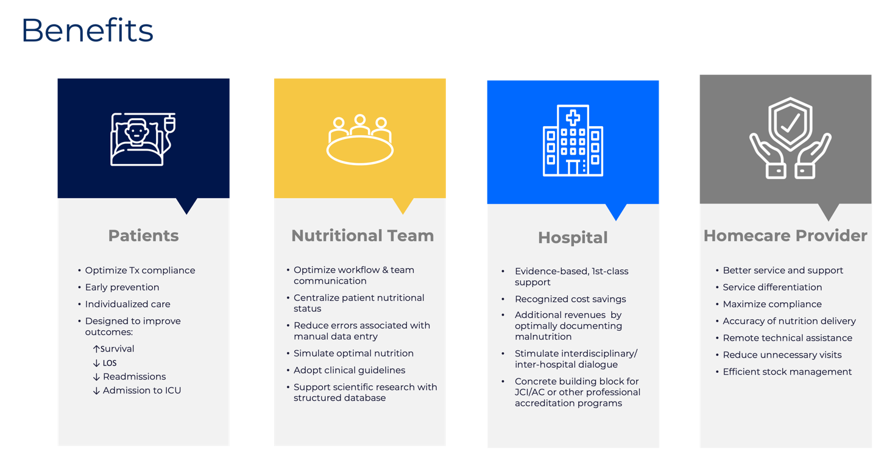
THE PROJECT
The project is based on the impact analysis of the use Dim3’s platform in the routine of an hosital ward(s).
It is thus an usability evaluation and not a clinical trial as impact on patient cannot be performed in this framework of project.

PROJECT PHASING
The project comprises 3 phases.
PHASE A: Protocol, Contracting, installation and operation
After definition of hospital stakeholder expectations and protocol and once collaboration contract is finalized, DIM3 installs and integrates its platform into Hospital IT system. Once installed, with connectors to the electronic patient record and users trained, DIM3 tools are used routinely for a maximum period of 12 months.

PHASE B: Assessment and data
Every 3 months and At the end of phase A, the various parties involved issue :
- An assessment report on the use of Dim3 products.
- Data on the impact and use of operators' time and satisfaction
- Clinical analysis data

PHASE C : Extension of use
If the results of phase B are positive, the Dim3 system will gradually be rolled out on

Meilleur remboursement par RHM documenté
Qualité percue de l’établissement
Tracabilité 100%

